Self Directed Support: The reality
‘The experience of SDS Implementation in East Scotland’
Wednesday 2nd November
10.30am – 2.30pm –Rothes Hall, Glenrothes Fife
10am: Tea and Coffee
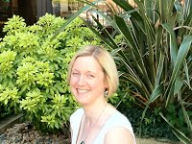
10.30am: Welcome from Self Directed Support Scotland
Setting the scene – SDSS Research - Aims of the day
10.45am: Looking at the difficulties and challenges for
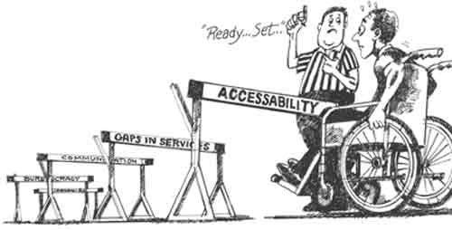
people trying to access support under SDS
11.30am: Coffee
11.45am: Looking at good practise
and it’s key features
12.30pm: Addressing the barriers to
accessing support under SDS (Part 1)
1.15pm: Lunch
1.45pm: Next Steps: Creating an Agenda for Change -
At a Local, Regional and National level (Part 2)
2.30pm: Finish

