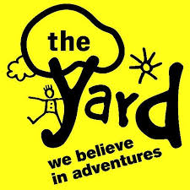

Care Inspectorate SDS Themed Inspection of East Lothian
Monday 28th October, Musselburgh East Community Learning Centre
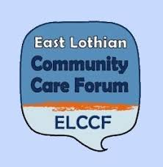
12 noon: Coffee and Lunch

12.30pm: Welcome and Introductions

12.40pm: Background to the Care Inspectorate SDS Themed Inspection:
- Why did the Care Inspectorate choose East Lothian?
- How was the Inspection undertaken?
- Who was spoken to?

12.50pm: The Care Inspectorate Report:
- What did the Care Inspectorate find?
- What conclusions and recommendations did the Care Inspectorate make?
- What does this mean for SDS Implementation in East Lothian?
- What does the Care Inspectorate expect the Health and Social Care Partnership to do next?
- How will the Care Inspectorate know if their Recommendations are implemented?
- What follow-up work will the Care Inspectorate do?
- How can local people be involved in supporting the Recommendations made?

1.10pm: Health and Social Care Partnership:
- Response to the Care Inspectorate Recommendations

1.40pm: Looking at the Recommendations:
- Round table discussions on the Recommendations made

2pm: Coffee and comfort Break

2.10pm: Recommendations – Next Steps:
- Responses and Ideas to the Recommendations made

2.30pm: How you can be involved in future discussions on SDS Implementation:

2.50pm: Recap – last questions – next steps
3pm: Finish

