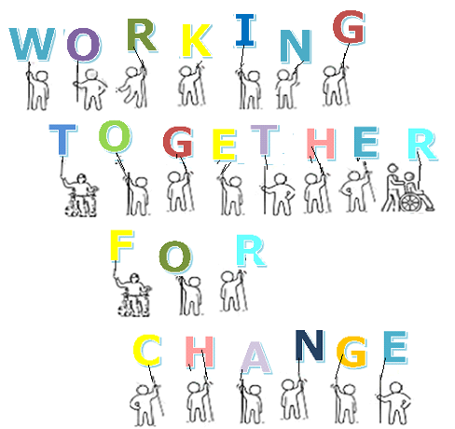

Working Together for Change Programme - Application Form



*If yes, please tell us who you are linking up with from your area:*

**In what capacity are you applying to the programme:**

Nos

yes

**Are you applying to the programme along with someone else from the same area?**

*Please tell us here if other:*

Carer

Local Authority

Disabled Adult

Sibling of Disabled Person

Other

Support Provider

Parent of Disabled Person

**Email Address:**

**Personal Details**

**Name:**

**Address:**

**Telephone No:**

Mobile:

**Please tell us why you have decided to apply for a place on the ‘Working *Together for Change*’ programme and what you would hope to gain from attending:**

**About the Programme**

**Please note: Closing date for applications is 16th December 2019 and we will let you know if you have been successful in being offered a place by Thursday 19th December 2019**

It is important that participants attend all 6 sessions of the programme, please check the programme descriptor for the dates of the programme and advise us of any session you would be unable to attend and the reason why.

**Will you require any additional support to attend the programme?**

**Do you have any accessibility requirements?**

**Date/Sessions**

**Sessions**

Signed:

Date:

**Please tell us more about your support here:**

No

Yes

Yes

No