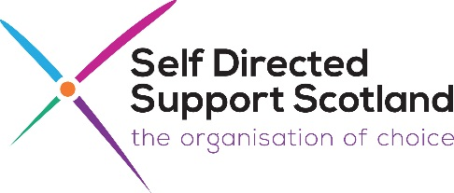
Disclosure (Scotland) Act: Information Session
Thursday 29th October: 12.30pm – 2pm

The new Disclosure (Scotland) Act came into law on 14th July 2020 and will change some aspects of the criminal records scheme. This online information session is being delivered by Disclosure Scotland and is aimed at anyone with an interest in the new Act, especially people who might be affected by any changes, such as PA Employers, Personal Assistants, Advocacy Organisations and Independent SDS Information and Support Organisations.

12.30pm: Introductions and Groundrules
12.40pm: Outline of the background to the Bill – why this was introduced

12.50pm: What the Bill has changed and what this means in practise
(Regulated Role; Registration; Level 1 and 2 Disclosures;
Accredited Bodies; Code of Practise etc)

1pm: Questions to be considered, including:
- How do changes to the Disclosure and PVG scheme offer greater protection to vulnerable groups?
- What information can a PA Employer now receive about a potential employee?
- What information can a PA Employer report to Disclosure Scotland if they have any concerns about a PAs practise?
- Can PA Employers recruit anyone if they choose to do so?
- Will a PA Employer be viewed as an Accredited Body and will they have to be Registered as part of the Disclosure Scheme?
- Do PA Employers have to request a Disclosure for family members they are looking to employ, if they are undertaking a regulated role?
- What will be the cost of applying to the new scheme?
- Will PA Employees who haven’t had a Disclosure check before need one now?
- Any other questions

1.55pm: Summary, last points, further information and resources available
2pm: Finish

If you would like to book a place for this session, please contact:
Mark Han-Johnston
Tel: 07775 065653
Email: mark@sdsscotland.org.uk

