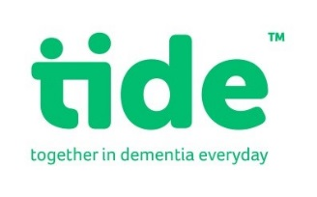

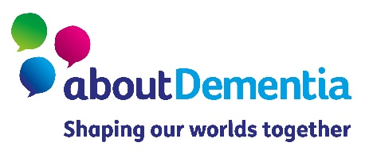
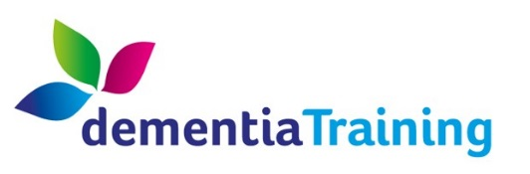

Self-Directed Support and Carers’ Rights – a webinar for International Carers’ Rights day 2020
15:00 – 16:30, Wednesday 25th November 2020

15:00 – 15:15 | Welcome and introductions  Sandra Brown, Age Scotland Dementia Training
15:15 – 15:35 | An introduction to Self-Directed Support for Carers  Mark Han-Johnstone, SDS Scotland
15:35 – 15:50 | A carer’s SDS journey  Eileen Alexander interviewed by Amanda McCarren, tide
15:50 – 16:00 | About Dementia and tide - Campaigning for carers’ human rights  Kainde Manji, About Dementia
16:00 – 16:30 | Question and answer session  All panellists
16:30 | Close

