NATIONAL SELF-DIRECTED SUPPORT COLLABORATION

NOTE OF MEETING – 29TH MARCH 2023

In attendance by video conference:
Donald Macleod (SDS Scotland) | Jenny Reekie (Community Brokerage Network) | Yvonne Nova (Scottish Government)
Agnes Hadden (Take Control) | Alison Upton (Scottish Social Services Council) | James McNulty (Scottish Government)
Fran Holligan (COSLA) | Andy Miller (Scottish Centre for Learning Disabilities) | Hannah McShane (Scottish Government)
Ashley Drennan (Inspiring Scotland) | Becs Barker (Community Contacts) | Heather Mole (Scottish Government)
Elspeth Critchley (Encompass) | Elaine Torrance (National Development Team for Inclusion) | Carrie-Anne French (East Ayrshire Council)
Jaynie Mitchell (Coalition of Carers) | Des McCart (Healthcare Improvement Scotland) | Rhonda Alexander (East Ayrshire Council)
James Carle (Scottish Care) | Karen McFadyen (Lothian Centre for Inclusive Living) | Claire Roxburgh (East Ayrshire)
James Cronin (Scottish Government) | Edward Inglis (SDS Forum East Renfrewshire) | Kayleigh Hirst (SDS Scotland)
Jill Fraser (Inspiring Scotland) | Joanne McGee (Take Control) | Joyce Campbell (Scotland Excel)
Laura Hendry (Cornerstone SDS) | Martin Kettle (Glasgow Caledonian University) | Les Watson (Personal Assistants Network)
Lisa Ehlers (Inclusion Scotland) | Louise Officer (Care Inspectorate) | Lyn Pornaro (Disability Equality Scotland)
Morag Duncan (Dundee Carers Centre) | Rob Gowans (Health and Social Care Alliance) | Pauline Lunn (In Control Scotland)
Susan Kelso (Personal Outcomes Network) | Laura Finnan Cowan (Social Work Scotland) | Sheila Hannay (Key)
Jane Kellock (Social Work Scotland) | Simon Webster (Coalition of Care Providers in Scotland) | Susan Chapman (Community Contacts)
Donna Murray (Social Work Scotland) | Calum Carlyle (Social Work Scotland) (minutes)
Welcome | Actions
DMd welcomed the group.

Apologies were noted from: Jennifer Rezendes, Margaret Petherbridge, Sharon McLeod, Alan Bigham, Becky Duff, Nicoletta Primo, Lisa Ehlers, Gordon Dodds, Rachael Grauwelman-Smith and Violet Keenan.

The previous meeting minutes were approved by assent.
No matters arising.

Self-directed Support Improvement Plan Update (JMy) | Actions
JMy presented on Scottish Government and COSLA’s newest iteration of the SDS Improvement Plan.

(double click to open this document)

The group were invited to look over the SDS Implementation Plan, which was circulated to members on Tuesday 28th March and to feed back by the end of next week (7th April 2023).

Questions and comments:

AU offered to broaden the activity in terms of worker skills, practice and autonomy. There is work going on around future proofing of the SSSC register. If we reference these as well as the Advanced Practice Framework this could strengthen the message in terms of CPL and training. JM offered to pick that up offline.

BB – Did we go down from 77 activities to 29? Where do those outcomes sit that have been removed, or have these been amalgamated together?
JMy – In a previous iteration we had an influx of ideas for activities in the plan, around 77. We agreed at that workshop that it would be appropriate to reduce that to a more manageable level, learning lessons from the previous plan that had around 36 activities/work streams. We wanted to be more confident in doing a small number of things well rather than a larger number not so well. It has been difficult to isolate a particular activity area since it might affect many others. Some of the activities have been amalgamated, and some have been expressed in a way that would allow some flexibility. We haven’t lost any of the activities, we will look to bring that back when budgets and capacity can support that and when it makes sense to do so. This makes the process of agreeing the plan more manageable, by focusing on the first year.
DMy – Can you say a bit more about what meaningful, legitimate user-focused evaluation would look like in terms of the plan?
JMy – An approach to evaluating this activity needs to be done at a slower pace and maybe doesn’t need to be in the plan. Perhaps this could be explored with a subgroup comprising of those with an expertise in evaluation. We hope to move away from a performance approach to a learning approach.

National Self-directed Support Stakeholder Updates | Actions
In Control (PL) – In Control will be doing more peer learning activities rather than one to one over the next year, and will be able to share more detail over the next couple of weeks. Evaluation continues for the Working Together For Change project. There seems to be about 50/50 support for in-person and online meetings, where a few months ago most wanted to stay online.
Evaluation also continues on the option 2 work in Aberdeen, and these will most likely come out as thematic learning reports.
The last SDS for Children and Families lunchtime session of the financial year will take place this Thursday, followed by a break in the lunchtime sessions for a short while.

The group agreed that there is a mix of reasons why people prefer in-person or online meetings, and that it depends on the type of event and type of audience.

SDS Scotland (DMd) – The SDS National Voice conference took place last Wednesday, with a number of presentations, one of the most successful being from someone who is a Community Broker, a Social Work student and a Personal Assistant (PA) employer. There was a good panel discussion as well as several workshops. More details can be found here (link).
PA Programme Board (DMd) – The board took a focus on three focused areas: Edinburgh and Lothians, Ayrshire and Aberdeenshire. Interviews will take place this week on the PA training framework. A newsletter has been published which is PA led.
The second annual PA workforce survey is about to be launched.
Recruitment is underway for the next two cohorts of the Community Brokerage Award.
Additional updates can be found on the PA Programme Board web page.

Social Work Scotland SDS Project team (JK, DM, LFC)
Direct Payment Collaborative Agreement for Employing PAs – The HSCP survey has now been completed and the data is to be collated by an independent analyst for the DP work stream group to look at. The data gathered will be used to start to form a model collaborative agreement to support PA employers and PAs.

The Wellbeing Group - two part time strategic improvement coaches coming from Impact to assist with the PA Wellbeing work, looking at how to best support PAs and PA employers.

SDS Practitioner Toolkit – This has been out for beta testing with Social Workers throughout Scotland and is now being refined and updated into its next iteration. This has been a collaborative venture, to help practitioners to find good resources quickly in the SDS Resource Library and elsewhere.

Self Evaluation Approach – This is a rough draft which is now ready for beta testing, and two Local Authorities (LAs) have volunteered to test this to see how easy it is to implement at a local level (Highland and East Ayrshire). This will happen over the next financial year taking a learning approach to that, not a performance based approach, since a learning approach will support and drive improvement. Once this testing is complete, this will go out to a wider group of LAs for further testing.

Review of SDS standards – the SDS standards were co-produced nearly two years ago, with the commitment to review them with a view towards island communities, rural and remote communities and equality. This is now in the planning stages, and National SDS Collaboration members are invited to contact the project team if they would like to be involved (sds.team@socialworkscotland.org).

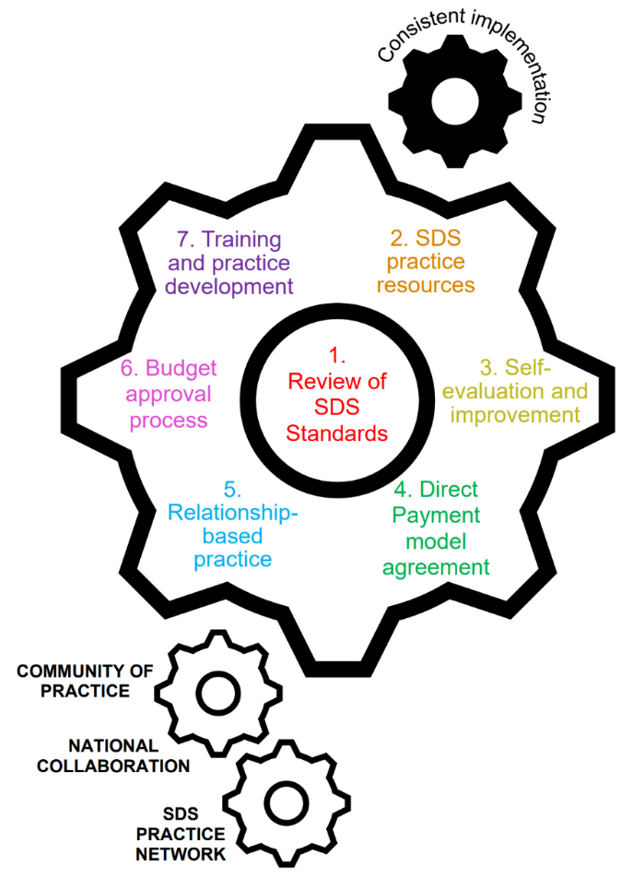
There was a very useful workshop at last week’s SDS National Voice event with some helpful feedback being aired. The SDS project have been working with Scottish Government colleagues to develop a work plan for the next financial year, and this is now virtually completed. The project are looking to develop around seven work streams with the review of SDS standards at their heart. At the next SDS Community of Practice meeting, members will be invited to come forward to join the work streams, and members of the National SDS Collaboration will also be invited to join as appropriate.

The seven workstreams are presented in the accompanying graphic.

Disability Equality Strategy Update (HM) – Heather Mole from the Equality, Inclusion and Human Rights Directorate, gave an update on the Disability Equality Strategy. Over the last year or so Scottish Government have been working on a Disability Equality Strategy to follow on from the Fairer Scotland For Disabled People Delivery Plan. The Minister invited the Scottish Independent Living Coalition to be part of the steering group. This group has met four times, and will meet for the fifth time on the 15th of April 2023. The steering group have begun to define the main priorities:
- Accessible services to enable independent living
- Tackling poverty in the cost of living crisis
- Promoting, supporting and protecting rights
- Communities and active participation
- Accessible places, spaces and the public realm

At the next meeting, the steering group will begin to identify actions under each of these priorities, as well as an idea of how each of these actions will play out in the short, medium and long term. This co-design process has taken longer than expected, with a big factor being the impact of COVID, which is still being felt, as well as the capacity issue, with all of the Disabled Peoples’ Organisations (DPOs) working to capacity at the moment. The framework is expected to be finished by November, at which point there will be a further period of consultation, to include disabled people and organisations that are not represented on the steering group, including some accessible events to encourage feedback.

The Minister for Social Security held a trilateral meeting recently, agreeing that there needs to be an urgent focus on the current issues affecting disabled people. A short life working group has been set up, with representation from Disability Equality Scotland, Glasgow Disability Alliance and Inclusion Scotland. The group has met once, with three more meetings planned before the end of May. The intention is to have something for Ministers to consider by the end of May.

Sarah Manson and Andrew Godfrey Jones will represent the Disability Equality Strategy going forward.

Inspiring Scotland Update (AD) - SiRD project budgets have been agreed for the year 2023-2024. We are also expecting a new SiRD programme to be announced this summer, with more details to come (for the period up to 2027). The National SDS Collaboration will be included when it’s time to consider the priorities for that.

Highlight Presentation – Community Brokerage Award (JRe) | Actions
JR presented to the group on the Community Brokerage Award. Please see the attached slides:
double click to access slides

Applications are now open for the next Community Brokerage Award, running from September 2023 to June 2024. Some marketing is planned via SDS Scotland and CBN’s various channels, so if you spot social media posts, could you please retweet/share? And if you know of individuals or networks that you think may be interested in the award, please think about making direct contact with them. The best way to share information about the Community Brokerage Award is by using this link.

Highlight Presentation – Learning Disability Week (AM) | Actions
This year’s Learning Disability Week theme is Leadership, which ties in with the SDS Improvement Plan’s recognition of the importance of leadership. Leadership is one of the ongoing workstreams within SCLD. In the SDS implementation plan highlights a focus on a person-centred and person-led approach, which raises the question of where leadership actually lies. We should be including the leadership of those who use SDS, not just those who plan or fund social care.

Inspiring Scotland and the Scottish Commission for People with Learning Disabilities (SCLD) have teamed up to create a leadership course for people with learning disabilities. It is called Our Future Leaders. The course is designed to help participants develop the skills and tools to make the choices that are going to help them live healthier, happier and more fulfilled lives.

Click here for more information including a short video with graduates of the course reflecting on how it has helped them to develop their leadership skills. AM reflected that SDS isn’t just about leaders or people using SDS, it’s about people working together at all levels to make SDS work, and that leadership skills are useful for anyone making decisions of any sort.

AM asked the group to think about what it will take for people to learn and develop the leadership skills they need to lead on the implementation of SDS, and how does this tie in to the activities of the SDS implementation plan?

Scottish Government Update | Actions
New Cabinet Secretary for Health and Social Care is Michael Matheson. SG team will be preparing to present SDS to the Minister adequately in due course, including potentially meeting with this group. Grant letters are being finalised at the moment as well as the SDS improvement plan.

Stage 1 of the National Care Service Bill has been delayed until June, with policy and preparation work continuing in the meantime.

Any Other Business | Actions
The next meeting of this group will be on Wednesday 10 May at 1pm. Click here to join the meeting.

