**Scottish Personal Assistant Survey 2025**

**Communications pack for partners**

Thank you for helping us spread the word about this year’s Scottish Personal Assistant Workforce survey.

Please use the templates in this pack to share across your communications channels.

1. **Text for contacting PA Employers**

**Calling all Personal Assistants Employers!**

We need your help to understand more about the Personal Assistant workforce in Scotland.

The Scottish Personal Assistant Workforce Survey 2025 is now live, and we need as many PAs in Scotland as possible to take part.

**Please can you help us by sharing this information with your PAs?**

The Scottish PA Workforce Survey aims to gather information about all PAs working in Scotland. This is the third time the survey has been carried out over the past few years, and the information gathered from previous surveys has been used to inform work to support PAs and Employers across Scotland.

The survey is a really important opportunity to recognise and understand more about the Personal Assistant workforce in Scotland.

Please pass on this information to your Personal Assistant(s) and encourage them to take part before the survey closes at 9am on Monday 5 May.

Thank you for your help!

**More information for PAs and the link to the survey:** [**https://www.sdsscotland.org.uk/news/scottish-personal-assistant-workforce-survey-2025/**](https://www.sdsscotland.org.uk/news/scottish-personal-assistant-workforce-survey-2025/)

1. **Text for contacting Personal Assistants**

**Calling all Personal Assistants!**

We need your help to understand more about the PA workforce in Scotland.

The Scottish Personal Assistant Workforce Survey 2025 is now live, and we need as many PAs in Scotland as possible to take part.

**As a thank you for taking part, you’ll have the chance to enter a prize draw to win one of five £100 Amazon vouchers!**

**Take the survey now:** <https://formtitan.com/s/w2s5?dist=7>

The survey asks you about your role, working conditions, how you feel about being a PA and what you think needs to happen to better support PAs and their Employers.

This is the third time the Scottish PA Workforce Survey has been carried out over the past few years, and the information gathered from previous surveys has been used to inform work to support PAs and Employers across Scotland. So please make sure your voice is counted.

If you completed the survey in the past, it’s really important you do it again this year – we want to understand what might have changed for you.

If you didn’t do it last time, we still really want to hear from you, so please take time to do the survey this year.

The survey is anonymous and takes around 10-15 minutes to complete.

It can be accessed any time up till 9am on Monday 5 May.

Thank you.

**Take the survey now:** <https://formtitan.com/s/w2s5?dist=7>

1. **Text for website posts**

**Calling all Personal Assistants!**

We need your help to understand more about the Personal Assistant workforce in Scotland.

The Scottish Personal Assistant Workforce Survey 2025 is now live, and we need as many PAs in Scotland as possible to take part.

**As a thank you for taking part, you’ll have the chance to enter a prize draw to win one of five £100 Amazon vouchers!**

**Take the survey here:** <https://formtitan.com/s/w2s5?dist=7>

The survey asks you about your role, working conditions, how you feel about being a PA and what you think needs to happen to better support PAs and their Employers.

This is the third time the Scottish PA Workforce Survey has been carried out over the past few years, and the information gathered from previous surveys has been used to inform work to support PAs and Employers across Scotland. So please make sure your voice is counted.

If you completed the survey in the past, it’s really important you do it again this year – we want to understand what might have changed for you.

If you didn’t do it last time, we still really want to hear from you, so please take time to do the survey this year.

The survey is anonymous and takes around 10-15 minutes to complete.

It can be accessed any time up till 9am on Monday 5 May.

Take the survey here: <https://formtitan.com/s/w2s5?dist=7>

1. **Social media posts**

Posts advertising the survey will be shared on Self Directed Support Scotland channels:

* Facebook: <https://www.facebook.com/SDSScotland>
* LinkedIn: <https://uk.linkedin.com/company/self-directed-support-scotland>

Please feel free to share these posts and/ or post your own using the templates below:

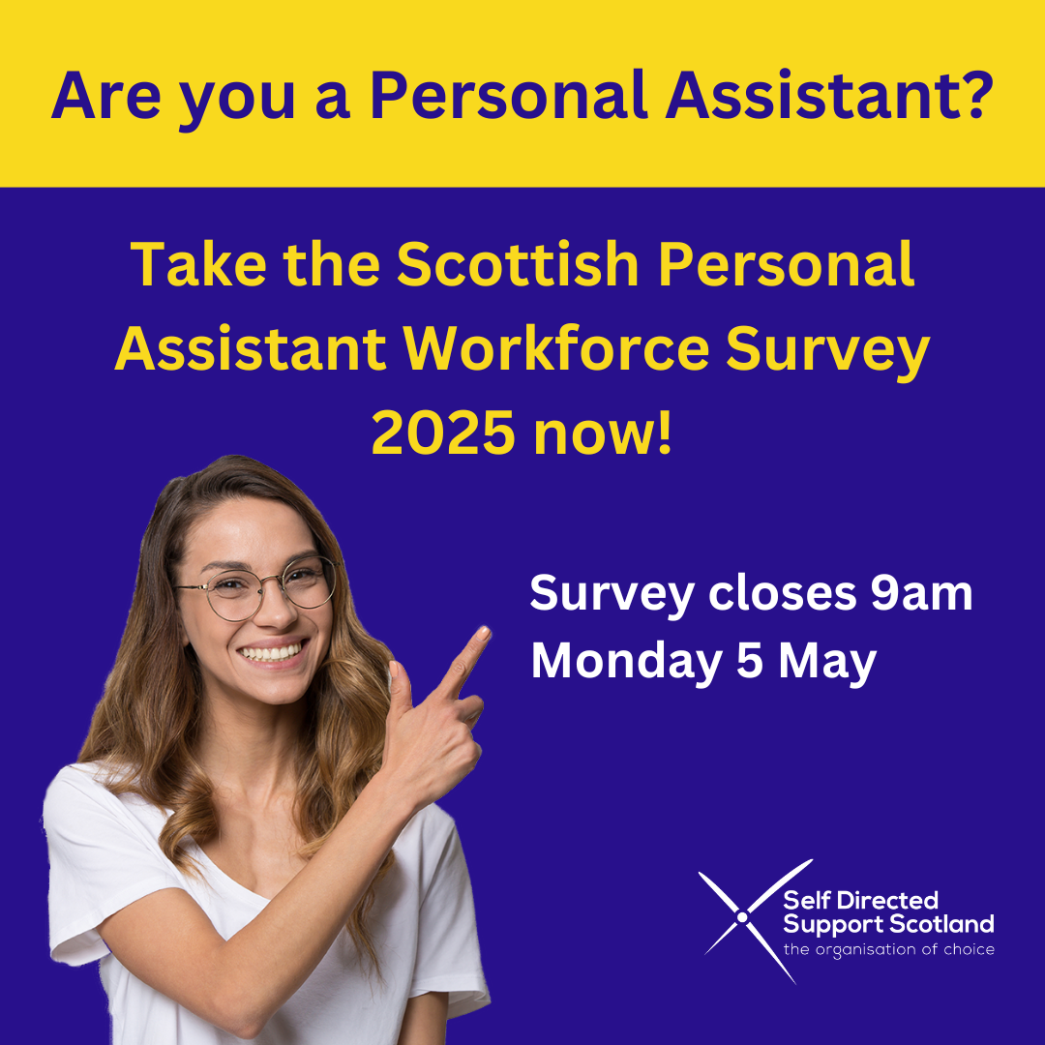

**Template posts for social media**

*The Scottish Personal Assistant Workforce survey is now live! We want to hear from all Personal Assistants working in Scotland to understand more about you, and how you find your role. The survey is open until Monday 5 May:* <https://formtitan.com/s/w2s5?dist=7>

*ICYMI, the Scottish Personal Assistant Workforce survey is now live! We want to hear from all Personal Assistants working in Scotland to understand more about you, and how you find your role. The survey is open until Monday 5 May:* <https://formtitan.com/s/w2s5?dist=7>

*Have you taken part in the Scottish Personal Assistant Workforce survey yet? If you're a PA in Scotland it's really important to make sure your voice is counted, to inform the work to support all PAs and their employers in future. Take the survey now:* <https://formtitan.com/s/w2s5?dist=7>

*Are you a Personal Assistant supporting someone in Scotland? We need your help! Please complete the national PA survey, to help us understand how we can improve things for PAs and their employers.* <https://formtitan.com/s/w2s5?dist=7>

*There are just a few days left to complete this year's PA workforce survey. If you haven't already, please take ten minutes to tell us about you and how you find your role - to help us improve things for all PAs and employers. Survey closes Monday 5 May.* <https://formtitan.com/s/w2s5?dist=7>

*[On Sunday 4 May]*

*🚨 Survey closing tomorrow morning! There are just a few hours left to complete the Scottish Personal Assistant Workforce survey. If you're a PA, make sure your voice is counted to inform work that will support all PAs and their employers. Take the survey now:* <https://formtitan.com/s/w2s5?dist=7>

**Longer post for Facebook/ LinkedIn**

*Are you a Personal Assistant supporting someone in Scotland? We want to hear from you! The Scottish Personal Assistant workforce survey is now live. We need just ten minutes of your time to help us understand more about you and how you find your role, so we can improve things for PAs and their Employers.*

*As a thank you for taking part you'll have the chance to enter a prize draw to win one of five £100 Amazon vouchers.*

*If you have completed the survey in previous years, it’s really important you do it again – we want to understand what might have changed for you. If you didn’t do it last time, we still really want to hear from you, so please take time to do the survey - it's really important we hear from as many PAs as possible.*

*The survey is open until 9am on Monday 5 May:* <https://formtitan.com/s/w2s5?dist=7>